Getting Started:

1. Locate Program.cs in the solution explorer.

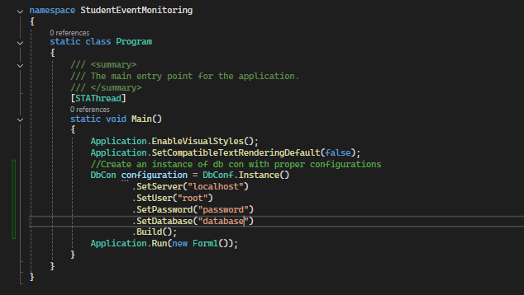

NOTE: .SetServer() can be excluded from the builder as it defaults to localhost.

1. In every form, include DbCon.Instance() to get the database context.

1. Use Case
2. In every form that will use the database, after retrieving the singleton instance of DbCon, you can perform various CRUD operation.
3. It is recommended to use try-catch block.

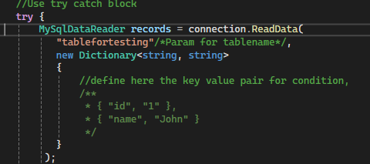

1. For example in read scenario, we pass the table name as string first, and for the second parameter we pass the key value pair. Key being the column name. and Value being the value we want to match.
2. If you’re expecting multiple records, use while loop, otherwise use if-else depending on the particular scenario that you want to implement.

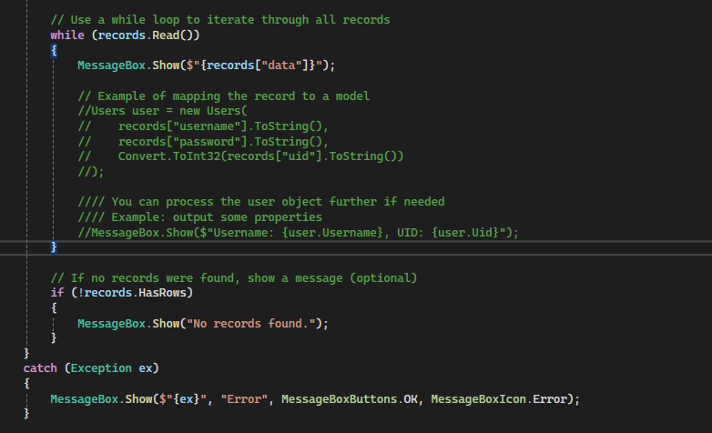

1. CRUD Operation
2. Create

1. Read

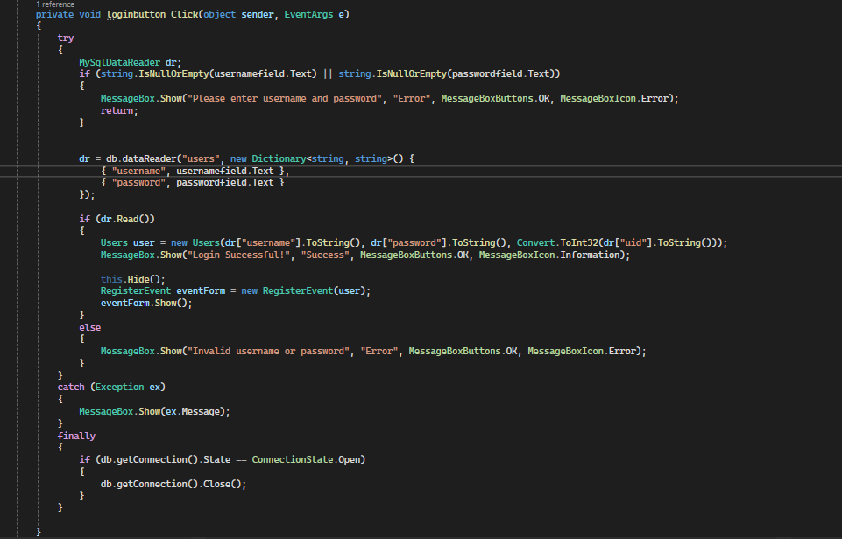

1. Update
2. Delete